MECH 431 - Engineering Economics: Midterm Examination 2020 Summer

Instructor: Mark Hollett Name: Ratthamnoon Prakitpong

Duration: ~60-90 minutes Student Number: 63205165

Instructions:

1. You may complete the exam in this document and submit it, or you may submit a separate answer document. Acceptable document formats are Word (and equivalent open formats), PDF, or scanned images. DO NOT SUBMIT SPREADSHEETS – copy any tables into your document if needed.
2. Ensure your name and student number are clearly indicated on your submitted document.
3. Submit the completed exam through the “Exams” module on Canvas. The exam must be submitted before the indicated due date and time. NO EXCEPTIONS WILL BE MADE. Ensure you leave yourself sufficient time to deal with flakey wi-fi and technical challenges, as well as formatting your file for submission. Technical difficulties will not be accepted as an excuse for late submissions.
4. This examination consists of 15 questions for a total of 45 marks. Please check that your examination file is complete.
5. This is an open book exam. You may use any textbooks, resources, calculators, and software you wish to complete it.
6. Indicate your answers clearly and show all your work. Your numerical answers must be accurate to the nearest dollar, and must include the correct units (e.g. 496.3 Kg. $1089).
7. Ensure your work is clear and readable. Severe readability issues may result in grade penalties.
8. The exam must be completed independently. Showing or discussing the exam with anybody is forbidden, including current and former students of this class. No discussion of exam questions will be permitted on Piazza. You may not post questions related to the exam on other discussion forums.
9. The following general UBC rules governing formal examinations will be in force:
10. You are not permitted to ask questions of the invigilators, except in cases of supposed errors or ambiguities in examination questions.
11. If you are suspected of any of the following, or similar, dishonest practices, you shall be immediately dismissed from the examination and shall be liable to disciplinary action:
12. having at the place of writing any books, papers or memoranda, calculators, computers, sound or image players/­recorders/transmitters (including cameras and phones), or other memory aid devices, other than those authorized by the examiners;
13. speaking or communicating with other candidates; and
14. purposely viewing the written papers of other candidates or exposing written papers to the view of other candidates or imaging devices.

The plea of accident or forgetfulness shall not be received.

Name of Marker: _______________________

|  |  |  |
| --- | --- | --- |
| Question | Possible Marks | Actual Marks |
| Short Answers (1-11) | 15 |  |
| 12 | 6 |  |
| 13 | 6 |  |
| 14 | 10 |  |
| 15 | 8 |  |
| Total | 45 |  |

Short Answers Not necessary to show calculations/written work.

1. [1 mark] Why does opportunity cost need to be considered when establishing a Minimum Acceptable Rate of Return?

MARR is the minimum return we’re willing to go ahead with on a new project. It is found by looking at current investment options, meaning that by investing in a new project, you lost the opportunity to continue investing with an established return. This lost investing opportunity can be considered as opportunity cost when establishing MARR.

1. [1 mark] What does marginal revenue represent? What are sunk costs?

Marginal revenue represents additional revenue per additional item sold. Sunk cost is costs that are spent in the past, before an analysis was done so it shouldn’t be regarded.

1. [1 mark] Economies of scale suggests that generally, as you produce more of something, the average cost of production will go down. However, in some cases producing more output results in increased average costs. Give an example of why this might happen for a factory producing widgets

In a widget factory, to produce more items, the factory has to pay workers overtime to increase production. If increased pay is greater than decrease in fixed costs averaging (ex: land rent per widgets made) and other marginal costs are constant (ex: no discount in material cost), then it will cost more than the current average to make an additional product, resulting in increased average cost. In other words, when average cost rises, marginal cost will be greater than average cost.

1. [1 mark] Create a cash flow diagram for the following: you take out a loan of $50,000 that is charging 10% simple interest. For the next ten years, you pay only the interest payments. In the tenth year, you pay back the loan principal and the payments end.
2. [2 marks] Why does the formula for Geometric Gradient Annuity Factor change when i = g? What is actually happening with a Geometric Gradient series of cashflows when i = g?

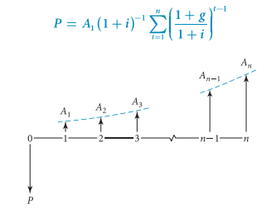Geometric Gradient Annuity Factor formula was derived from this equation. Since the term to be summed is changed, summation result will change, so the derived formula will change. When derived i=g case, however, a better way to derive this formula is not from the above equation, but to add up each annuity, and simplify from there:

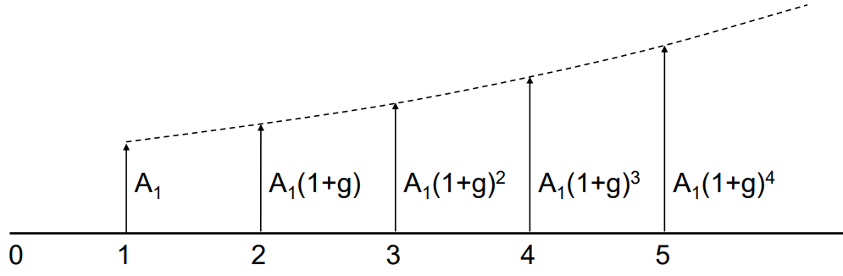

P = A1 + A2 + … + An

= A1 (1(P/F,i,1) + (1+g)(P/F,i,2) + … + (1+g)n-1(P/F,i,n))

= A1 (1/(1+i) + (1+g)/(1+i)2 + … + (1+g)n-1/(1+i)n)

= A1 (1/(1+i) + (1+i)/(1+i)2 + … + (1+i)n-1/(1+i)n)

= A1 (1/(1+i) + 1/(1+i) + … + 1/(1+i))

= A1 (n/(1+i))

The intuition is that increase in payment (geometric gradient) is at the same rate as the lost value of money (interest rate), so increase in present worth will be constant. We just multiply that constant amount of A1 /(1+i) by number of periods.

1. [1 mark] Why are book costs not included in the cashflows when doing a cashflow analysis?

Book costs is a way of recording past costs in the accounting books, so it’s not representative of actual cash flowing, therefore it’s not included in cash flow analysis. An exception is when asset depreciation (a common book cost) affect taxes, which results in cash flow.

1. [1 mark] BC Hydro is building a small dam and want to capitalize the cost of operating and maintaining it. The estimated annual costs are $50,000, and BC Hydro’s interest rate is 10%. If the dam is expected to last forever, how much should BC Hydro invest to capitalize the operating and maintenance costs?

This type of investment is called perpetuity.

Perpetuity = Annuity / Interest rate

= $50000/10%

= $500000

1. [2 marks] Determine the Internal Rate of Return for the following series of cashflows:



IRR is the interest rate where NPV is zero. We can find NPV at each interest rate by summing each cash flow after it’s converted to present value at some interest rate. Sign doesn’t matter as long as it’s consistent, because we’re only looking for zeros. Plotting those NPVs give us this:

We can interpolate to get IR of approximately 49.34% and 119.21%. Without the two external rate of returns, we couldn’t calculate modified internal rate of return to confirm which value is accurate, but we can guess that interest rates aren’t usually as high as over 100%, so we can say with some certainty that it’ll be 49%.

1. [1 mark] Why does the value of an investment decrease when interest rates increase?

Investing means spending money now to make future money. Intuitively, interest rate is the price value of future money; new, increased interest rate means that money now is worth less and future money is worth more, when compared to when your investment is made. Therefore, your investment is devalued since you could’ve gotten more future money when investing with the new interest rate.

1. [2 marks] You determine the NPV of a project with an analysis period of one year and an interest rate of 18%, and it is positive, indicating the project is financially worthwhile. If you were to determine the Equivalent Annual Uniform Cashflow (EAUC) for that project, would the EAUC be larger, smaller, or the same as the NPV? Why?

Same since EAUC is per one year, and our analysis period already is one year.

1. [2 marks] Below is a chart showing the NPV vs Interest Rate for two projects under consideration. Project A costs $10,000. Project B costs $18,000. What is the incremental rate of return on Project B (to the nearest percent)? If your MARR is 24%, which alternative (if any) should you select?



You should select neither, since both options’ NPV is negative at 24% interest.

Show ALL your work for questions 8-15.

1. [6 marks] Calculate the Future Worth of these three sets of cashflows at the end of five years, with 9% interest, compounded semi-annually.

A: $100 per month

B: $100 in the first month, increasing $2 per month thereafter

C: $100 in the first month, increasing 1% per month thereafter

n = 5 year * 2 times / year = 10 periods

1 + iperiod = (1+ 0.09/2)2/12 = 1.007363

iperiod = 0.007363

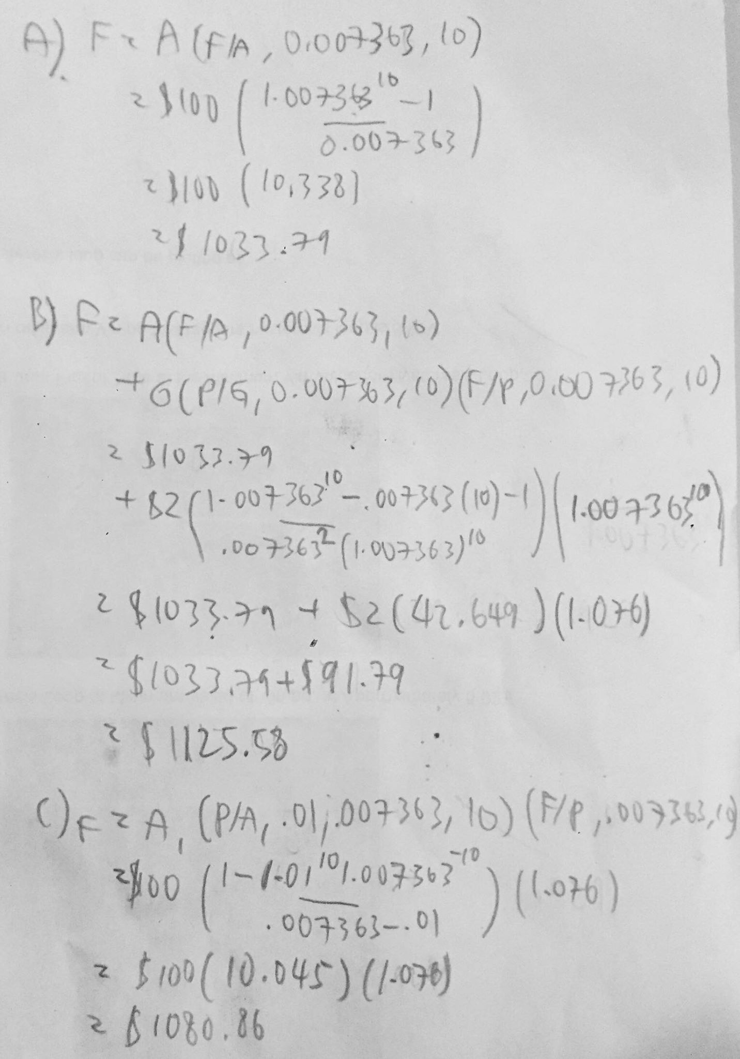

1. [6 marks] You are starting a small software company developing an application for unspecified nefarious purposes. Between yourself and two software developers, you have total monthly wages of $15,000. Your small office in Hawaii costs $2400 per month in rent and utilities.

You license your software to client companies at $1,000 per month. You outsource your customer support, and based on expected volumes you estimate each client will cost you an average of $300 per month in support costs.

1. [3 marks] Calculate how many clients you need to break-even on a monthly basis.

Fixed cost = wages + rent = $15000 + $2400 = $17400

Variable cost = $300 / client

Marginal revenue = $1000 / client

At break even, total costs equals total total revenue:

Fixed cost + Variable cost * Number of clients = Marginal revenue * Number of clients

$17400 + $300 n = $1000 n

n = $17400 / $700 = 24.857 = 25 clients

Check:

Total cost = $17400 + $300 * 25 = $24900

Total revenue = $1000 * 25 = $25000

Total revenue > Total cost

1. [3 marks] What is your average cost per client at the breakeven point? If you double the number of clients from there, what is the new average cost per client?

Average cost per clients = Total cost / Number of clients

Average cost at 25 clients = $24900 / 25 clients = $996 / client

Average cost at 25*2 clients = Average cost at 50 clients = $24900 / 50 clients = $498 / client

1. [10 marks] You are trying to decide between manufacturing a part using injection molding machine or using a 3D printer. The 3D printer option will cost $3,000 in capital, has an annual operating cost of $2,000, and annual benefits of $4,000.

The Injection Molding machine will cost $16,000 in capital, but have an annual operating cost of only $750 and an annual benefit of $4,000.   
Your interest rate is 12% per year. The 3D printer has a useful life of 2 years, the Injection Molding Machine has a useful life of 10 years. Neither machine will have any salvage value after its life is up.

A: [8 marks] Which alternative should you select based on a Present Value analysis?

The life of two alternatives are not equal. In this case, there’s a reasonable and neat common denominator of 10 years (5 lives for 3D printer, 1 life for injection molding), so we can pick that as our analysis period. We’ll assume that we can get new printers at at least this price in the next 10 years (this assumption will be discussed in more depth in part B).

We’ll subtract annual costs from annual benefits to simplify calculations.

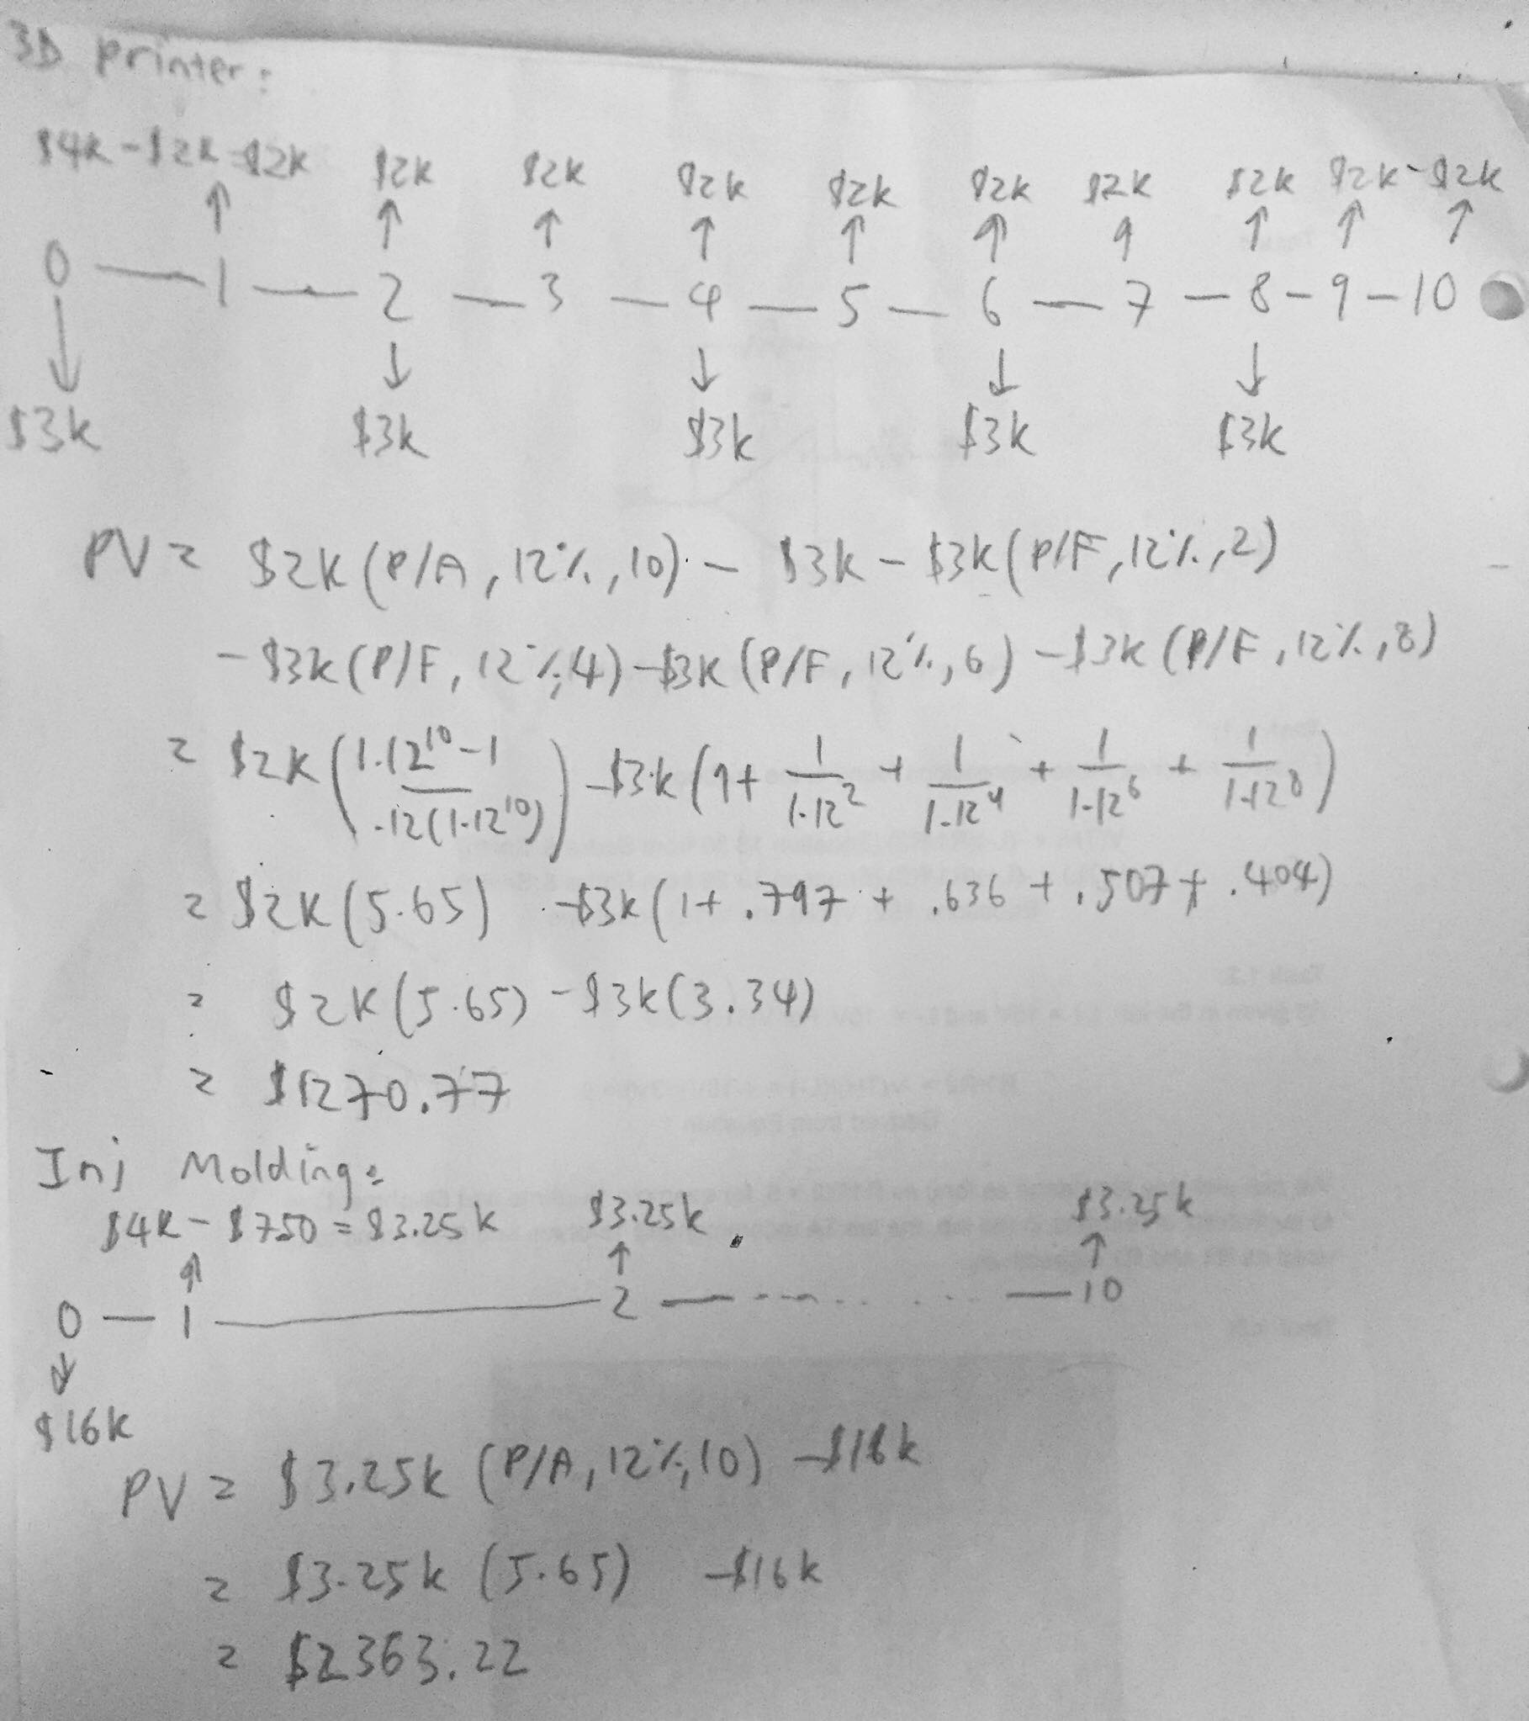

We can see that injection molding provides higher present value, so we should go with it.

B: [2 marks] Suppose the specific 3D printer you have selected will be obsolete in two years’ time, so you will not be able to replace it. But given the trajectory of 3D printing technology, you expect even better printers to be available for less cost. Discuss (no calculations or numbers needed) how this would (or would not) affect your previous analysis.

A main assumption we made is that we could get printers for the same cost in the next 10 years, so lowering printer costs will lower overall costs and increase present value of 3D printing. To approximate lowered costs, we can set up a spreadsheet to plot 3D printing’s PV per varying price of 3D printer, either by some percent or by some fixed amount per year. The plot’s inflection point would be where PV is equals to injection molding’s PV; any further price reduction will make 3D printing more viable.

1. [4 marks] For both project option in the previous question, plot the NPV vs i for interest rates up to 25%.

[4 marks] What is the IRR for each option? What is the Incremental IRR? If your MARR is 12%, would your recommendation change from your Present Value analysis in question 14?

IRR is the interest rate where PV is zero, given an option’s costs and benefits. Instead of iterating guesses, we can interpolate from the plot above to get the approximate IRR:

3D printing IRR = 21.5%

Injection molding IRR = 15.5%

Incremental IRR is the interest rate where PV is zero, given the difference between two options’ costs and benefits (subtracting higher initial cost option by lower initial cost option). Instead of recalculating everything, we can subtract plots and interpolate where the difference plot has zero PV:

Incremental IRR = 14.05%

Since incremental IRR of 14.05% more than MARR of 12%, we would not change our recommendation of selecting injection molding as the option.